Exercise 1
IHW#1: Your firm – Overview of your firm’s strategy, business risks, and performance metrics
aka – IHW: Your firm’s strategy

Due on ________________
Points possible ________________.

The purpose of this HW is to extend your understanding of your firm’s (1) industry, (2) business strategy, and (3) performance metrics. In the process of identifying these aspects for your firm you will increase your familiarity with the contents and components of your firm’s annual report.

Requirements: In this HW you are asked to do the following.

Read Chapter 1 of Financial Reporting: First-Take

Read Chapter 5 Financial Reporting: First-Take

Browse your firm’s annual report: You may want to focus on the (a) letter to shareholders, (b) section on risk factors, and (c) MD&A section.

Provide responses to this set of requests (please read all the questions before beginning).

Provide (a) the name of your firm and (b) the location(s) of its headquarters and primary operations.

What industry is your firm in? You may want to use the library resources listed in the attached description. In addition, the website http://biz.yahoo.com/p/industries.html may help you with this question (enter your firm’s ticker symbol at this site to see if your firm is included in the data set).

What are the general economic characteristics of the industry? For example, how many firms are direct competitors to your firm? You may want to refer to industry surveys, such as S&P industry survey, available on-line from the Kopolow Library (see next pages for directions for accessing the Kopolow Library databases).

Describe your firm’s customers? Are there some customers that are critical to the firm’s success?

Describe your firm’s suppliers? Are there some suppliers that are critical to the firm’s success?

What is your firm’s business strategy? What are your firm’s core business activities (what are the primary ways your firm makes money)?

Describe the performance metrics your firm uses to measure its progress / successes / objectives (metrics such as ‘return on assets,’ ‘return on equity,’ ‘EBITDA,’ ‘net income,’ etc.). Do you believe that these are metrics that measure appropriately the business strategy? Why?

The suggested length of your responses should be approximately one to two paragraphs for each item. Try to use your own words in the write-up, but if you do quote verbatim from a source, please clearly provide appropriate citations.

Attachments. The next pages provide information useful to complete this IHW, including:
- Kopolow Business library resources: Summarizes data sources you can use in this course
- Two ‘example solutions’ to give you some perspective as to the expectations for this IHW.

After you have completed this exercise you should be able to succinctly summarize (1) your firm’s strategy and (2) the core economic aspects of its industry.

To help you achieve this objective, we provide
Two different Example Solution

Solution Example #1: Pages 5 to 7 and
Solution Example #2: Pages 8 to 11

These example solutions and not strict requirements. You are encouraged to be creative in your solution.

EXAMPLE SOLUTION #1

IHW#1: Your firm – Overview of your firm’s strategy, business risks, and performance metrics
aka – IHW: Your firm’s strategy

Name: Ron King - EMBA #xx (by association): Group W

Firm: My firm is 3M. This firm is headquartered in St. Paul, Minnesota and incorporated in the state of Delaware. It has a global presence, and as of 12/31/10 had more than 80,000 employees (with about 33,000 employed in the U.S.). 3M reports net sales of $26.6 B for 2010 and over $30 B of total assets at 12/31/10. The firm had 711,977,608 shares outstanding, with a market price per share of $81.73 (http://finance.yahoo.com/) as of 12/31/10. This equates to a total market value of equity of $58.2B ($81.73 * 711,977,608). 3M is one of 30 companies in the Dow Jones Industrial Average and is also a component of the Standard & Poor’s 500 Index.

4.1 What industry is your firm in?

Based on the website http://biz.yahoo.com/p/industries.html, 3M belongs to ‘Conglomerates’ industry.

According to (http://en.wikipedia.org/wiki/Conglomerate_(company)), “A ‘Conglomerate’ is a combination of two or more corporations engaged in entirely different businesses that fall under one corporate structure (a corporate group), usually involving a parent company and several (or many) subsidiaries. Often, a conglomerate is a multi-industry company. Conglomerates are often large and multinational.”

3M has the characteristics listed above. Specifically, 3M discloses in its annual report that it has six segments as shown in Exhibit A below (reproduced from page 115 of 3M’s 2010 annual report).

Exhibit A: 3M’s Business Segments

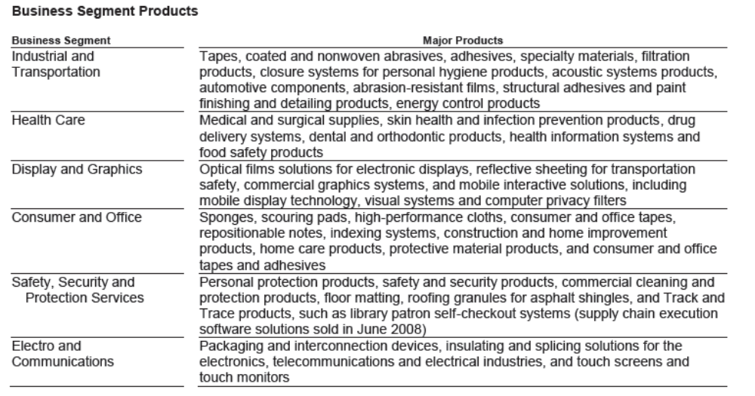

4.1 What industry is your firm in? (continued)

3M provides financial data on these six segments on the bottom of page 115 of its 2010 annual report.
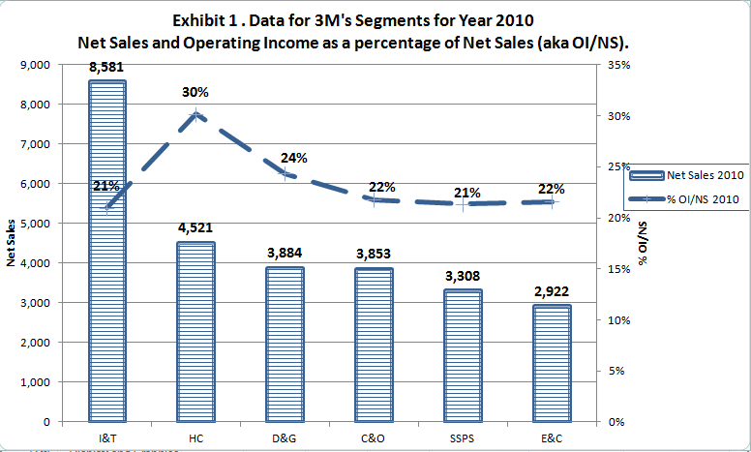
Using the data on page 115, I created Exhibit 1. This exhibit shows that the ‘Industrial and transportation’ segment had $8,581M in net sales, the highest of the six segments. The size of the net sales for each segment is shown at the top of each bar and the dollar value is depicted on the left-hand axis.

We can also see that this segment had 21% operating income as a percent of net sales. Operating income percentage is shown as the dashed line with the values shown on right-hand side of the graph.

The value of 21% operating income percentage means that for every one dollar of net sales, this segment produced 21 cents of operating income. We can see that the ‘Health care’ segment was the second largest in terms of net sales (at $4,521) but had a 30% operating income percentage which is the highest of all the six segments. This suggests that 3M may want to focus on this segment when considering future investments.

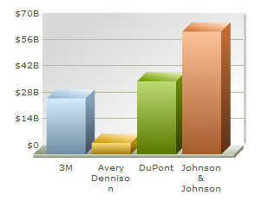
Exhibit 2. 2011 Annual sales
4.2 General economic characteristics of the industry?
The industry is comprised of a small number of large multinational firms along with many smaller firms that focus on particular segments. Across 3M’s six operating segments, there are approximately 19 direct competitors for 3M, three of which are identified as top competitors based on the extent of product overlap:
1. Avery Dennison;
2. Dupont; and
3. Johnson & Johnson.

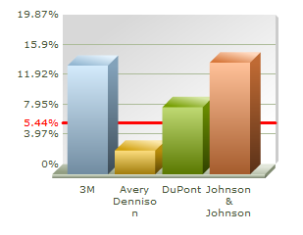
Exhibits 2 and Exhibit 3 (from Hoover’s database) compare the four companies in terms of annual sales and net profit margin for the year 2011.Among the four firms, 3M ranks 3rd and 2nd with respect to annual sales and net profit margin. Note that 3M’s profit margin is about the same as Johnson & Johnson (JNJ), resulting from JNJ and 3M’s high profitable HealthCare segment (as evidenced by Exhibit 1 above).
Exhibit 3. 2011 Net Profit Margin

“3M’s market share is approximately 4.66% among all its 19 main competitors in terms of gross revenue, and 21.24% among the three top competitors mentioned earlier” (MorningStar analysis).

4.3 What is your company’s business strategy? 3M business strategy can be summarized as follows (taken from 3M’s annual report and various analyst reports):

- Innovative culture. R&D constitutes an important part of 3M’s activities and has been a major driver of 3M’s sales growth. R&D totaled $1.434 billion in 2010 and $1.293 billion in 2009. 3M’s ability to innovate new pillars and to leverage the technology across multiple industries forms the backbone of its historical success. As a result, the firm has enjoyed returns on invested capital well above its estimated cost of capital during the last 10 years, while annual free cash flow averaged an impressive 15% of sales.

- Bottom-line focus. One example is that CEO George Buckley utilized 3M’s strong cash flow to pursue attractive acquisition opportunities. Since his arrival in 2005, 3M spent about 4% of sales per year to purchase outside companies, versus only 3% the five years prior.

- Low-cost manufacturing. While perfecting its manufacturing technologies, 3M also seeks to internationalize its production process to acquire the benefit of tax reduction. In 2011, non-North American sales constituted about two thirds of the company's overall revenue, a substantial increase from 53% in 2000, and up from 61% in 2006. In this manner the company's effective tax rate continues to drop as it rapidly moves into lower-tax geographies.

4.4 What are your company’s core business activities?
Through innovation and research, 3M develops and manufactures products in mainly six industries, namely Industrial and Transportation, Health Care, Consumer and Office, Safety Security and Protection Services, Display and Graphics, and Electro and Communications. After being manufactured, 3M products are sold through numerous distribution channels, including directly to users and through numerous wholesalers, retailers, jobbers, distributors and dealers in a wide variety of trades in many countries around the world (3M_MorningStar Analysis).

4.5 What are the performance metrics your company uses to measure its progress? Are they appropriate?
In the CEO letter to shareholders’ George Buckley indicates that metrics of interest include
- Organic sales growth (i.e., sales that come about without counting acquisitions)
- Operating profit (i.e., operating income divided by net sales)
- Earnings per share (i.e., net income divided by number of shares outstanding)
- Free cash flow (i.e., cash remaining after investing in growth)
These performance metrics seem appropriate with regard to implementing its business strategies.
Example Solution #2
IHW#1: Your firm – Overview of your firm’s strategy, business risks, and performance metrics
aka – IHW: Your firm’s strategy

Name: Bill Smith - EMBA #xx (by association): Group B

Mead Johnson Nutrition Company
Headquarters | Glenview, Illinois
State of Incorporation | Delaware
Employees as of 12/31/2016 | 7,600 worldwide
Net Sales (2016) | $3.743 Billion
Total Assets (2016) | $4.088 Billion
Shares Outstanding as of 2/27/17 | 183,429,210
Market Price/Share as of 2/27/2017 | $87.50 (Source: Google Finance)
Market Value of Equity | $16.06 Billion
Agreement reached with Reckitt Benckiser (RB) to be acquired on 2/10/2017
Acquisition voted on and finalized by Board of Directors on 6/15/2017
Day 1 of Mead Johnson Nutrition, a division of RB on 6/19/2017
 | 
www.meadjohnson.com | www.rb.com
Reckitt Benckiser
Headquarters | Slough, U.K.
Employees as of 12/31/2016 | 35,000
Net Sales | 9.9 Billion British Pounds ($13B USD)
Total Assets | 19 Billion British Pounds ($23B USD)

4.1 What industry is your firm in?

Mead Johnson Nutrition (MJN) is a very unique company. Of all of our competitors in the infant formula market, we are the only pure-player. By pure-player, I mean that we are focused only on infant formula and nothing else.

If you were to research our company, you would see many different analysts categorize MJN in several different industries as seen in the table below:

Source | Industry
Forbes | Household/Personal Care
Bloomberg | Food Beverage & Tobacco
Wikipedia | Pediatric Nutrition
Morningstar | Packaged Foods
MJN Annual Report | Pediatric Nutrition

Pediatric Nutrition is certainly the most apt descriptor of the industry MJN competes in. 99% of MJN sales fall into two categories: Infant Formula (59%) and Children’s Nutrition (40%). These categories can be broken down further into the following 5 categories:

Category | Description
Routine Infant Formula | Premium infant formula for infants without special dietary needs
Solutions Products | Addresses common feeding tolerance products such as gas or spit-up
Specialty Products | Addresses serious medical needs such as allergies or premature birth
Children’s Nutrition Products | Further development products for toddlers and older children
Other Products | Pre-natal and post-natal nutritional supplements for mom and baby
4.1 What industry is your firm in? (cont.)

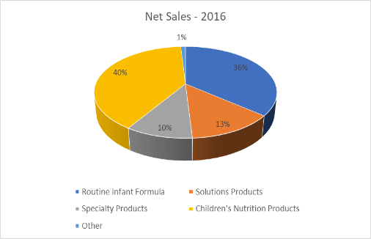
Here you can see a breakdown of net sales in 2016 as pulled from the annual report by category.

It comes as a surpise to many in developed markets how strong of sales MJN has in the toddler and older children’s market. You must rememebr to take into account that not all areas have an abundance of cow’s milk in local markets which most children migrate to around 1 year of age whether they were breastfed or formula-fed. This represents $1.48 B in revenue.

4.2 General economic characteristics of the industry?

MJN’s competition in the premium infant formula market have a much more broad product portfolio, but industry analysis, as pulled from factset.com, shows how competitive MJN is in their return on assets as seen in the below chart.

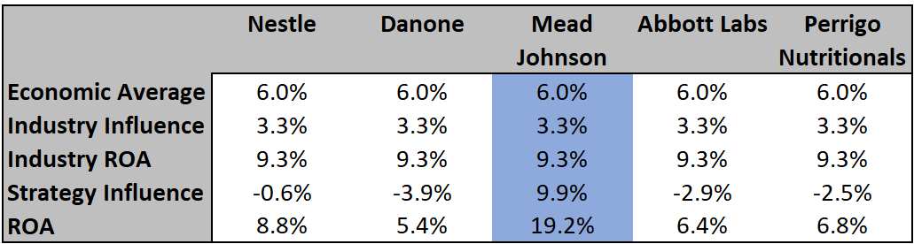

As can be seen in this chart, MJN has a significant strategic influence on the market to the point where its competitors are all catching up. Based on internal knowledge of MJN and the industry, this is due to our vast investment in R&D which Morningstar lists as approximately $100MM/year.

4.2 General economic characteristics of the industry? (cont.)

As stated in the annual report and shown in the 2016 net sales chart below from Statista, MJN is still the global leader in annual premium infant formula sales. MJN’s combined sales of these top brands are $1.294B compared to Abbott ($1.234B) and Nestle ($0.451B).

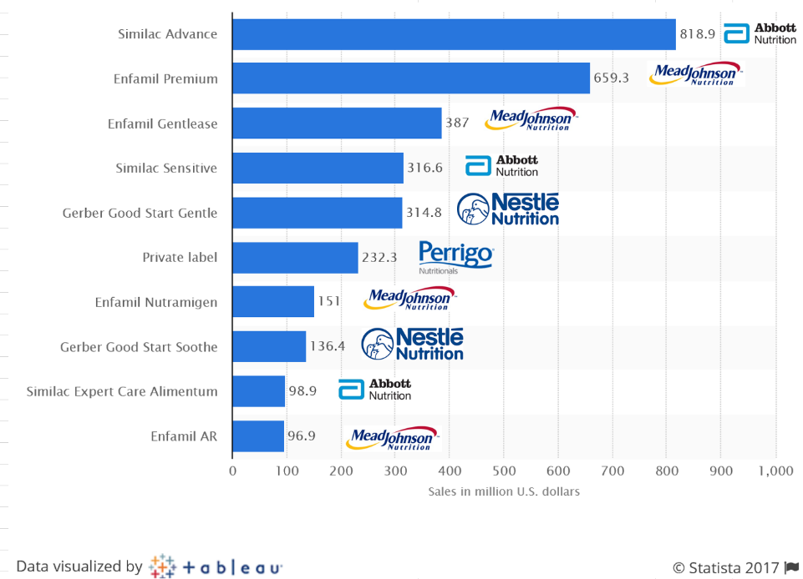

While MJN leads in global sales of premium infant formula, the competition has picked up market share primarily due to acquisition as can be seen in this chart from seekingalpha.com. As reported in fortune.com, Danone acquired Chinese infant formula maker Yashili International for $535 MM in 2014 in an attempt to gain market share in China, one of the world’s most populous countries. This after a couple failed attempts to acquire MJN. In 2012, Nestle made a huge spash in the infant formula market share with a purchase of Pfizer’s infant formula business for $11.9B as reported by the New York Times. This move by Nestle overtook MJN as the market leader in China.

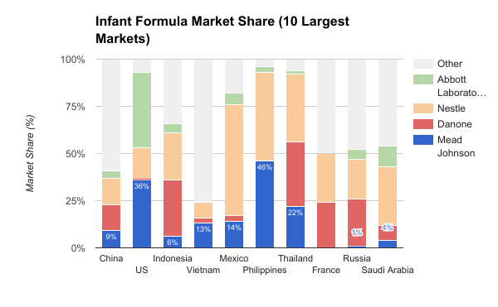

4.3 What is your company’s business strategy? MJN’s business strategy is focused to maintain our competitive advantages in key areas. As described in the annual report, they are as follows:

- Research & Development. Significant investment in R&D has been a major contributing factor to the success of our products. MJN has spent on average $107MM in R&D over the past 3 years. The R&D workforce is spread around the globe in the US, Mexico, China, Thailand, the Netherlands and Singapore. These R&D centers globally spread enable us to focus our R&D efforts for the markets for which we primarily market our product in. The scientists that work at MJN are focused solely on infant and child nutrition.

- Sales and Marketing. While this is a competitive advantage at this time, it is one that our competitors may catch up with eventually should they invest in the technology we have. One of the most sought-after technology solutions is developing a 360 degree view of the customer. At MJN, we not only have this in place for the customer (mom), we also have this in place for the consumer (baby). Through our engagements with moms via our global web presence, we capture, store and analyze data about both mom and baby that we use to connect moms with products that meet their baby’s needs. We have invested heavily in this digital platform, and it is paying dividends by enrolling increasing numbers of mom’s into our marketing campaigns.

- Intellectual Property. MJN has many patents across many of the countries we choose to do business in. Key ingredients and formulation patents that are used in products is the primary target for patents. Our goal is to stage these patents such that expiration of any patent would not create an exposure for our competition to impact our business. One such example is the use of lactoferrin and milk fat globule membrane (MFGM) ingredients in our super-premium product Enspire. The process to extract these key ingredients from cow’s milk is patented, and only one company we subcontract from does this process which we have monopolized the market as their only customer to purchase it. These key ingredients are what makes our product the closest thing to breastmilk on the market.

4.4 What are your company’s core business activities?
Through innovative R&D, MJN has developed a new product using key ingredients none of our competition can reproduce. This product was launched in late 2015, and we have seen steady growth in 2016 in sales of this super-premium product according to the letter from the CEO, Kasper Jakobsen, to the shareholders. We continue to invest in our digital strategies to interact with our customers in this digital age. Continued cost cutting measures have been taken in order to reduce SG&A and increase net operating margin.

4.5 What are the performance metrics your company uses to measure its progress? Are they appropriate?
In the CEO letter to shareholders’ Kasper Jokobsen speaks to the three metrics that were committed to:
- A return to growth (i.e., organic gross sales increases)
- Operating expense reduction (i.e., reduction in OPEX by both reduced spending and reduction in force)
- Reinvestment in growth initiatives (i.e., increased spending in advertising & promotion programs)
These performance metrics seem appropriate in order to implement our business strategies.

The annual report that you should use for the course is discussed in the pre-course activities memo. If you have not already done so, please see this memo for a discussion of the general requirements of your annual report firm.

